**Invite 2010 Reunion**

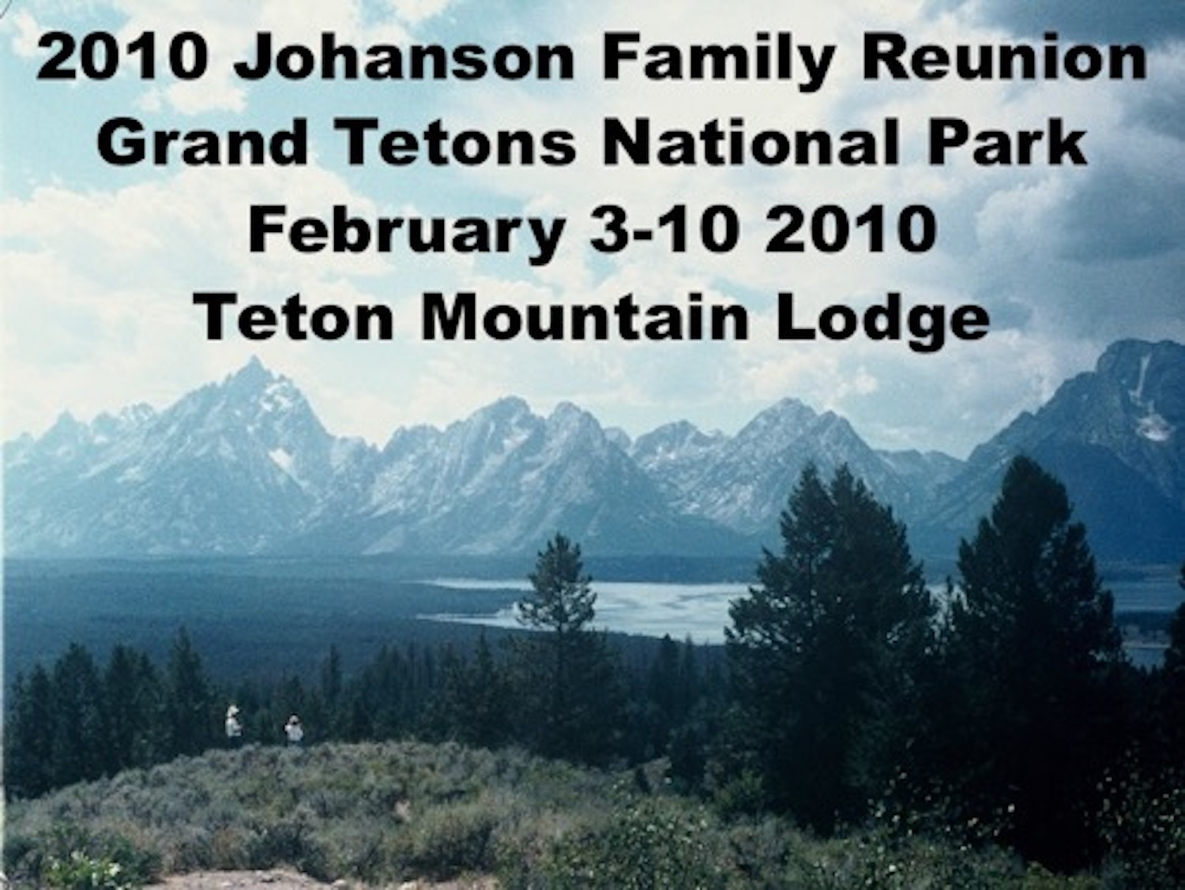

Dear Johanson Family Members:

It’s that time again. More than fourteen years have passed since we last met at Yellowstone. We are putting behind us the tragic events of those days and moving forward with new optimism. Come to the Grand Tetons and see! This reunion will be extraordinary. We will have a special guest to speak to us at the kickoff Friday family dinner. Be sure to arrive by 5:00 PM Friday!

There have been 14 babies born, and 12 family members have died since that last reunion in 1995. We'll renew our family ties this year at Jackson Hole near the Grand Tetons in Wyoming the week of February 3-10, 2010. We are starting on Wednesday so you can all be there by Friday night. We've made 28 lodge room reservations in the Teton Mountain Lodge. The winter activities at the lodge include Snowmobiling, Dog Sledding, Snow Shoeing, Ice Skating, Sleigh Rides, Tubing, Cross Country Skiing, Wildlife Expeditions, Incredible Food and getting wet in Pools and Hot Tubs. To make reservations, call the resort and tell them you want rooms from the Johanson block. Plan to arrive on the 4th or early on the 5th because we’ll have our very special first meal together as a family on Friday, February 5. The reservation phone number is in the enclosed brochure. See all of you in Jackson Hole in February.

**Timothy Johanson**