**Graves at First Baptist**

The first read: Malcolm (Big Boss) Longe. Born March 12, 1938. Died January 29,1994. Greatest Mayor Ever of Rextonville, Mississippi.

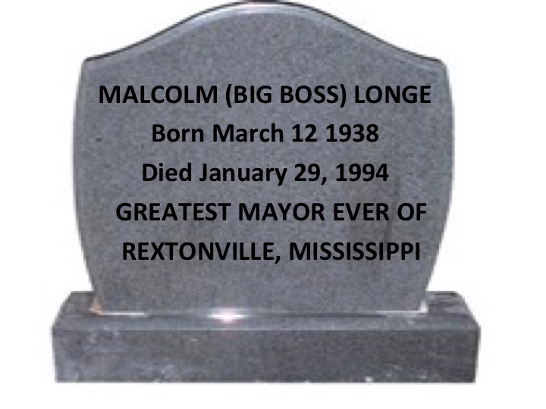

The second stone next to it read: Sally Anne Graham. Born September 8, 1984. Died October 29, 1994. She passed too soon. Sally was loved by All.

