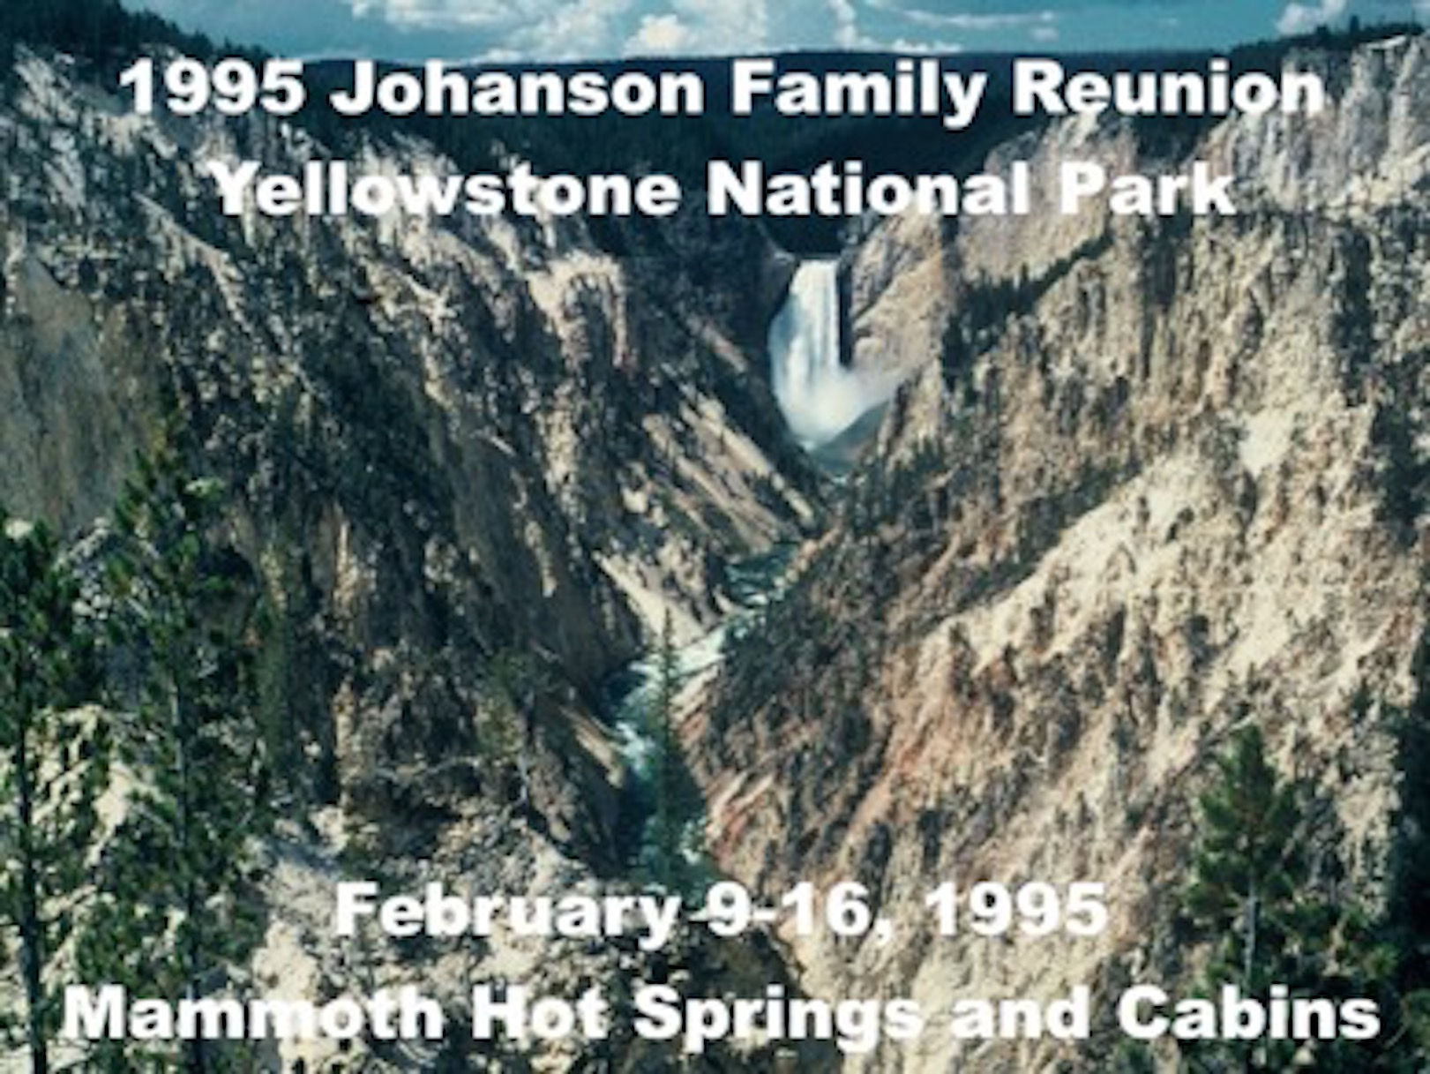

Dear Johanson Family Members:

It’s that time again. More than four years have passed since we last met in Philadelphia. There have been six babies born, and four family members have departed us since our last reunion. We’ll renew our family ties this year at Yellowstone National Park in Wyoming the week of February 9-16, 1995. We’ve made room reservations for 22 rooms and three cabins at the Mammoth Hot Springs & Cabins. In the winter, this is one of the few places to stay in Yellowstone since most of the park is closed to cars. Call the resort and tell them you want rooms or a cabin from the Johanson block to make reservations. Plan to arrive on the 9th or early on the 10th because we’ll have our first meal together as a family on Friday, February 10. The reservation number for the Hotel is in the enclosed brochure. See all of you in Yellowstone in February.

Jason and Bethany Johanson